VISUALIZATION TOOL FOR ELECTRIC

VEHICLE CHARGE AND RANGE ANALYSIS

NAAN MUDHALVAN PROJECT

Thiruvalluvar university

BACHELOR OF SCIENCE IN PHYSICS

Submitted by

N. PARAMESHWARI

(Reg No:13220U28002)

Email Id:priyasurya0703@gmail.com

S. SARGUNAM

(Reg No:13220U28003)

Email Id:sargunamajay@gmail.com

S. SUGANYA (TEAM LEADER)

( Reg No:13220U28004)

Email Id :suganyaselva3020@gmail.com

Under the guidance of

Ms. R. SARANYA M. Sc., M. Phil.,

SREE BHAVANI COLLEGE OF ARTS AND SCIENCE (Co-Ed).

KANDAPPANKURICHI

APRIL -2023

1.**INTRODUCTION**

A vehicle that can be powered by an electric motor that draws electricity from a battery and is capable

of being charged from an external source and have an electric motor instead of an internal

combustion engine.

The Electric Vehicle (EV) is not new, but it has been receiving significantly more attention in recent

years. Advances in both EV analytics and battery technologies have led to increased automotive

market share. However, this growth is not attributed to hardware alone. The modern mechatronic

vehicle marries electrical storage and propulsion systems with electronic sensors, controls, and

actuators, integrated closely with software, secure data transfer, and data analysis, to form a

comprehensive transportation solution. Advances in all these areas have contributed to the overall

rise of EV’s, but the common thread that runs through all these elements is data analytics.

The new EV’s are combined Electrical storage and propulsion systems with electronic sensors,

controls, and actuators, integrated closely with software, secure data transfer to form a

comprehensive transportation solution.

This is used for skill development for students.

2. **PROBLEM DEFINITION AND DESIGN THINKING.**

**2.1 EMPATHY MAP**

An Empathy map is a simple easy to digest visual that capture knowledge about a user's behaviors and attitudes.

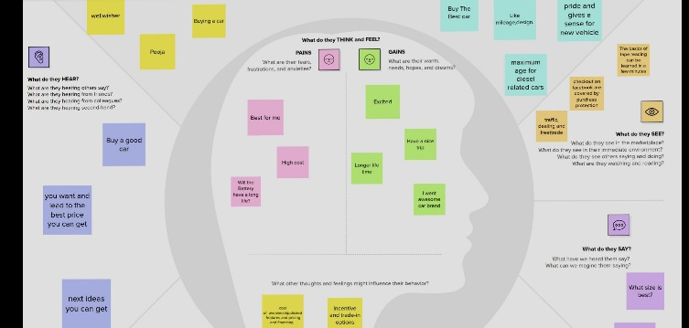

Figure:Empthy map.

2.2 **IDEATION & BRAINSTORMING MAP**

A mind map is visualization technique and brainstorming tool which allows you to explore a central idea, and all of it’s related topics in a now linear way.

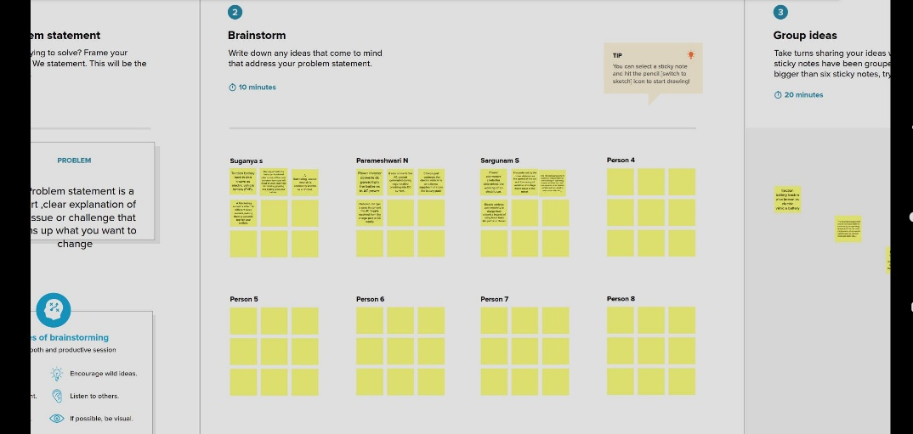

Figure:ideation and brainstorm.

**3.RESULT**

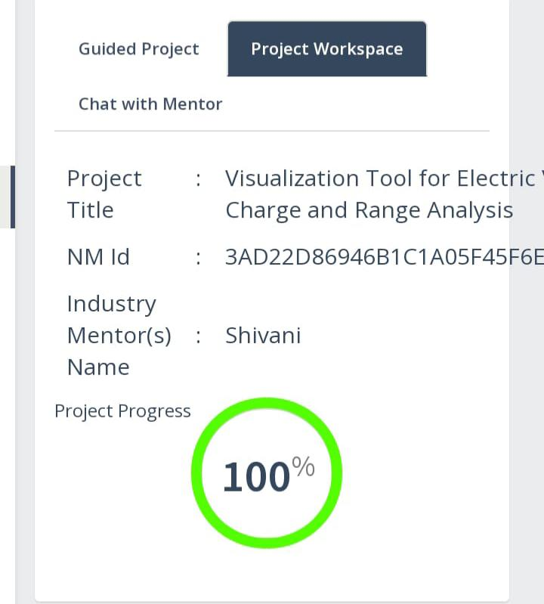

4. **ADVANDAGES & DISADVANTAGES**

4.**1 Advantages:**

**\* Easy to making ideation and thinking.**

**\* This is creating many projects for all categories.**

**4.2 Disadvantages:**

**\* Many errors are occurred.**

**\*Long procedure.**

**5. APPLICATIONS**

**\* It is used for job orientation line.**

**\* It is used in digital world.**

**6.CONCULATIONS**

**The procedure videos are seen. Step to step followed that instructions and**

**Making the empthy map and ideation &brainstorming map download the file. The project**

**Workspace are completed. The GitHub account was opened and the working files are**

**Submitted.**

**7.FUTURE SCOPE**

**The Smartinternz can speedup the process of moving you toward your**

**Career goals.**

**8.APPENDIX**

**Code : https://smartinternz.s3.amazonaws.com/NM_Arts_DA_HTML_Bootstrap_Links.pdf**